**Tamil Nadu**

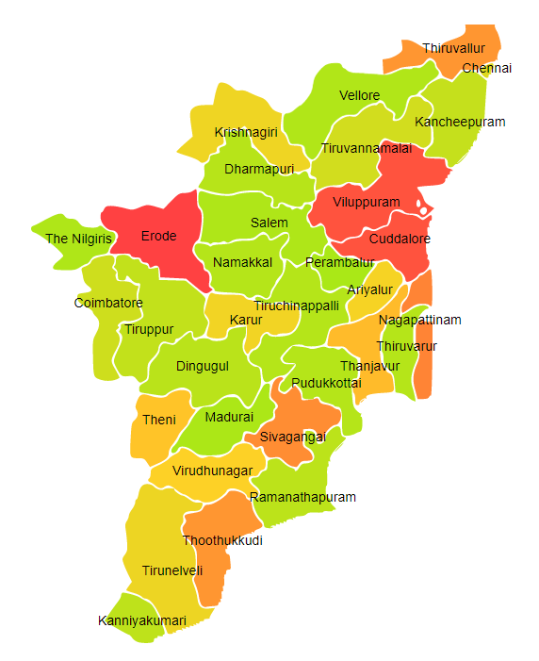

Tamil Nadu comprises of three Agro Ecological Regions (AER) 8,18 & 19.

**Agro-Eco Region 8:** AER 8 in Tamil Nadu comprises of Ariyalur, Coimbatore, Cuddalore, Dharampuri, Dindigul, Erode, Kanyakumari, Kanchipuram, Karur, Krishnagiri, Madurai, Namakkal, Perambalur, Pudukkottai, Ramanathapuram, Salem, Sivaganga, Teni, Thanjavur, Tirunelveli, Tiruppur, Tiruchirappalli, Tiruvallur, Tiruvannamalai, Tuticorin, Vellore, Villupuram and Virudhunagar districts of Eastern Ghats under Agro Ecological Sub Regions (AESR) 8.1,8.2 & 8.3.

**Agro-Eco Region 18:** AER 18 in Tamil Nadu comprises of Chennai, Nagapattinam, Ramanathapuram, Thiruvarur, Cuddalore, Kanchipuram and Tiruvallur districts of Eastern Coastal Plain under Agro Ecological Sub Regions (AESR)18.1 &18.2 .

**Agro-Eco Region 19:** AER 19 in Tamil Nadu comprises of Coimbatore, Kanyakumari and Nilgiri districts of Western Ghats & Coastal Plain under Agro Ecological Sub Regions (AESR)19.2 & 19.3.

**Major NRM issues :**

**AESR 8.1:** The region is hot dry semi-arid ESR with moderately deep to deep, loamy to clayey, mixed Red and Black soils, medium AWC and LGP 90-120 days in a year.

|  |  |  |  |  |
| --- | --- | --- | --- | --- |
| **Districts** | ***Land degradation*** | ***Soil health & fertility*** | ***Water related constraints*** | ***Environmental constraints*** |
| Coimbatore | Exclusively water erosion & Exclusively acid soils | Low in OC, Soil Deficient in N & P | Saline GW Contaminated with F & NO3 | **-** |
| Dindigul | Exclusively water erosion & Acid soils under water erosion | Low in OC, Soil Deficient in N | Saline GW Contaminated with F, NO3 & heavy metals | **-** |
| Kanyakumari | **-** | Low in OC, Soil Deficient in N | GW Contaminated with NO3 | **-** |
| Madurai | Exclusively water erosion | Low in OC, Soil Deficient in N | GW Contaminated with NO3 | Moderately prone to Flood & Drought |
| Ramanathapuram | Coastal Salinity | Low in OC, Soil Deficient in N | Saline GW Contaminated with F, NO3, As& Fe | **-** |
| Teni | Exclusively water erosion | Low in OC, Soil Deficient in Zn, Fe, S, N & P | Saline GW Contaminated with F, NO3 & heavy metals | Moderate vulnerability to Drought |
| Tirunelveli | Exclusively water erosion & Coastal Salinity | Low in OC, Soil Deficient in Zn, N & B | Saline GW Contaminated with F, NO3 & As | Highly prone to Flood & Drought |
| Tiruppur | - | Low in OC, Soil Deficient in N & P | Saline GW Contaminated with F & NO3 | Highly prone to Drought |
| Tuticorin | **-** | Low in OC, Soil Deficient in N, Fe, B & P | Saline GW Contaminated with F, NO3 & As | **-** |
| Virudhunagar | **-** | Low in OC, Soil Deficient in Zn, Fe, B, S, N & P | Saline GW Contaminated with F & NO3 | Moderate vulnerability to Drought |

**AESR 8.2:** The region is hot moist semi-arid ESR with medium to deep Red loamy soils, low AWC and LGP 120-150 days in a year.

|  |  |  |  |  |
| --- | --- | --- | --- | --- |
| **Districts** | ***Land degradation*** | ***Soil health & fertility*** | ***Water related constraints*** | ***Environmental constraints*** |
| Krishnagiri | **-** | Low in OC, Soil Deficient in N & P | Saline GW Contaminated with F | **-** |

**AESR 8.3:** The region is hot moist semi-arid ESR with deep red loamy soils, low AWC and LGP 120-150 days in a year.

|  |  |  |  |  |
| --- | --- | --- | --- | --- |
| **Districts** | ***Land degradation*** | ***Soil health & fertility*** | ***Water related constraints*** | ***Environmental constraints*** |
| Ariyalur | Exclusively water erosion | Low in OC, Soil Deficient in N & S | GW Contaminated with As | Moderate vulnerability to Drought |
| Cuddalore | Coastal Salinity | Low in OC & Soil Deficient in B, S & N | Saline GW Contaminated with NO3, As & heavy metals | High vulnerability to Flood & Drought |
| Dharampuri | Exclusively water erosion | Low in OC, Soil Deficient in Fe, B, S, N & P | Saline GW Contaminated with F & NO3 | **-** |
| Erode | - | Low in OC, Soil Deficient in Zn, Fe, B, S, N & P | Saline GW Contaminated with F , NO3 & heavy metals | Moderately prone to Drought |
| Kanchipuram | Coastal Salinity | Low in OC, Soil Deficient in N & B | Saline GW Contaminated with F , NO3 & heavy metals | **-** |
| Karur | Exclusively water erosion | Low in OC, Soil Deficient in N & B | Saline GW Contaminated with F & NO3 | Moderately prone to Drought |
| Krishnagiri | - | Low in OC, Soil Deficient in N & P | Saline GW Contaminated with F | **-** |
| Namakkal | Exclusively water erosion | Low in OC, Soil Deficient in B, S, N & P | Saline GW Contaminated with F , NO3 & Fe | Moderately prone to Drought |
| Perambalur | Exclusively water erosion | Low in OC, Soil Deficient inFe, B, S, N & P | Saline GW Contaminated with F & NO3 | **-** |
| Pudukkottai | Coastal Salinity | Low in OC & Soil Deficient in N | Saline GW Contaminated with F , NO3 | **-** |
| Salem | Exclusively water erosion | Low in OC, Soil Deficient in N & P | Saline GW Contaminated with F, NO3 | **-** |
| Sivaganga | - | Low in OC, Soil Deficient in Zn, Fe, Cu & N | Saline GW Contaminated with F , NO3 | **-** |
| Thanjavur | - | Low in OC, Soil Deficient in B & N | Saline GW Contaminated with F , NO3 | Highly prone to Flood, Drought & Cyclone |
| Tiruchirappalli | Exclusively water erosion | Low in OC, Soil Deficient in B & N | Saline GW Contaminated with As | **-** |
| Tiruvallur | Exclusively water erosion | Low in OC & Soil Deficient in N | Saline GW Contaminated with F , NO3 , As & heavy metals | **-** |
| Tiruvannamalai | - | Low in OC & Soil Deficient in N | Saline GW Contaminated with F & NO3 | **-** |
| Tuticorin | - | Low in OC, Soil Deficient in N & P | Saline GW Contaminated with F , NO3 & As | **-** |
| Vellore | - | Low in OC, Soil Deficient in N & P | Saline GW Contaminated with F & As | **-** |
| Villupuram | Exclusively sodic soils | Low in OC & Soil Deficient in N | Saline GW Contaminated with F & NO3 | **-** |

**AESR 18.1:** The region is hot dry semi-arid ESR with deep, loamy to clayey, alkaline Coastal and deltaic alluvium-derived soils, medium AWC and LGP 90-120 days in a year.

|  |  |  |  |  |
| --- | --- | --- | --- | --- |
| **Districts** | ***Land degradation*** | ***Soil health & fertility*** | ***Water related constraints*** | ***Environmental constraints*** |
| Ramanathapuram | Coastal Salinity | Low in OC, Soil Deficient in N | Saline GW Contaminated with F , NO3 & As | **-** |

**AESR 18.2:** The region is hot moist semi-arid ESR with deep, clayey and cracking Coastal land Deltaic alluvium derived soils, high AWC and LGP 120-150 days in a year.

|  |  |  |  |  |
| --- | --- | --- | --- | --- |
| **Districts** | ***Land degradation*** | ***Soil health & fertility*** | ***Water related constraints*** | ***Environmental constraints*** |
| Chennai | **-** | **-** | Saline GW Contaminated with NO3 | Highly prone to Flood & Cyclone |
| Nagapattinam | Waterlogged | **-** | Saline GW Contaminated with NO3 & As | High vulnerability to Flood, Drought & Cyclone |
| Thiruvarur | Exclusively water erosion | Low in OC & Soil Deficient in N | Saline GW Contaminated with F & As | **-** |

**AESR 19.2:** The region is hot moist subhumid to humid transitional ESR with deep, loamy to clayey Red and Lateritic soils, low to medium AWC and LGP 210-270 days in a year.

|  |  |  |  |  |
| --- | --- | --- | --- | --- |
| **Districts** | ***Land degradation*** | ***Soil health & fertility*** | ***Water related constraints*** | ***Environmental constraints*** |
| Coimbatore | Exclusively water erosion | Low in OC, Soil Deficient in N & P | Saline GW Contaminated with F & NO3 | **-** |
| Kanyakumari | Acid soils under water erosion | Low in OC & Soil Deficient in N | - | **-** |
| Nilgiri | Acid soils under water erosion | Soil Deficient in N | GW Contaminated with NO3 | **-** |

**Organization and Establishments for Technology Backstopping**

***ICAR Research Institutes/KVKs:***

|  |  |
| --- | --- |
| Regional Station of Indian Institute of Soil & Water Conservation, Ooty. | <http://www.cswcrtiweb.org/index1.html?Ooty/Ooty_back.htm> |
| KVK Portal | <https://kvk.icar.gov.in/> |

***SAUs/CAUs:***

|  |  |
| --- | --- |
| T[amil Nadu Agricultural University, Coimbatore](http://www.tnau.ac.in/) | [https://tnau.ac.in//](https://angrau.ac.in/) |

***List of KVKs:*** <https://icar.org.in/content/tamilnadu>

***List of Soil testing Laboratories****:* <https://farmer.gov.in/STLDetails.aspx?State=33>